Supplementary Section
Study Methods
Participants’ could access the survey via a dedicated link on the ABC news webpage, with connecting links posted across various ABC entities
Sample Media Recruitment:
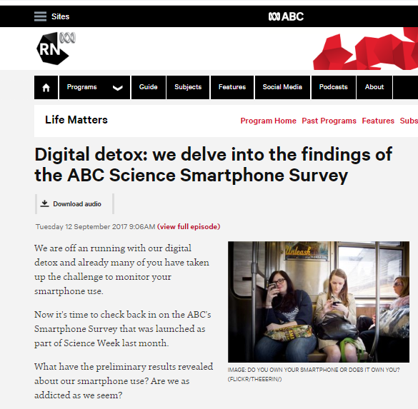
Sample Social Media recruitment (Facebook, left; Twitter, right):
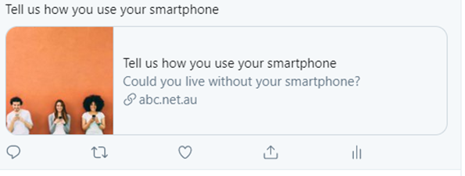
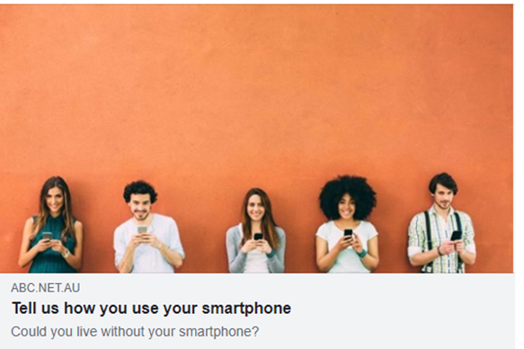

Survey link via Smartphone:
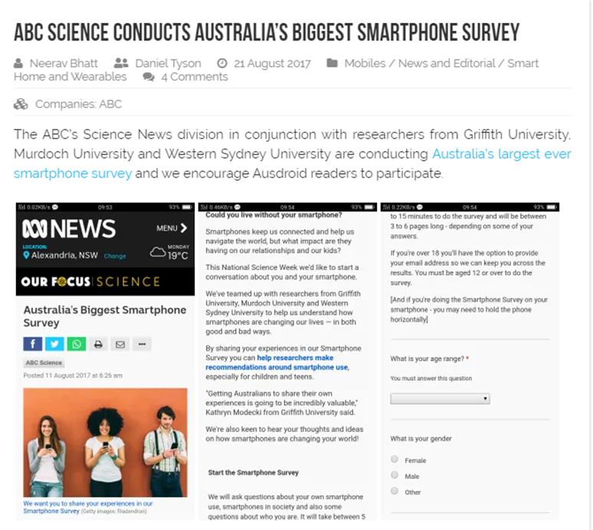
Study Procedure and Data Cleaning
The survey was live for two weeks, and was hosted by PollDaddy, using the ABC’s professional account. The ABC retained user name and password data for the site. PollDaddy uses enhanced security that is SSL- Secure Socet Layer. SSL protocol have been created for secure data transmission over the Internet network. This feature meant that Polldaddy sent secured survey links (URL) and exported survey results using a secured channel. Privacy policy is available here: https://polldaddy.com/privacy/.
The ABC took responsibility for all privacy and data security requirements. After the survey closed, the research team sought ethics approval to receive a copy of the data. These were provided to the research team, who then took responsibility for cleaning and analyzing the data.
Given study data were based only participants who answered “yes” to the prompt “Do you have children living at home” and who then provided eligible responses to an open-ended question regarding the age of their youngest child in their household (entered responses from 0-18), we were not overly concerned about bots contributing to these data. Moreover, lack of financial renumeration for survey completion likely served as a deterrent. That said, as a quality check, we further included two quality control elements, including checking for a) IP address not located oversees and postal code located within Australia and b) a speed trap, such that no responses were under 4 minutes of completion time. Within our data sub-sample, no participant exclusions were required.
Prior analyses
A number of items within this investigation were used, descriptively, within an early conference presentation focused on a study overview and project methods. Thus prior to the current investigation we were aware of certain correlations between some aspects of parental use and family stress, as well as descriptive statistics. However, this was without applying a full battery of control variables and prior to having obtained a fully cleaned data set.
Further, as a preliminary phase of this study, and in line with a growing literature in highly powered, transparent analyses of technology-wellbeing data, we ran a full analysis of many possible forking paths (862 analyses; Steegen, Tuerlinckx, Gelman, & Vanpaemel, 2016). Similar to screening experimental designs (Box, Hunter & Hunter 1978), this helped to clarify non-sensible model choices. As noted by these authors the “garden of many forking paths” can never be exhaustively examined, rather the researcher must impose sensible bounds on model choice.
This is not a meta-analysis per se, although it uses the same models as meta-analysis. Here we conduct a sensitivity analysis, a tradition that spans quantitative modelling paradigms for examination of model settings. For this purpose, the fixed effect models, which are of similar structure (but different interpretation) to those applied to meta-analysis, can be used as a descriptive tool for summarizing how standardised effects vary across model settings, accounting for within and between model-settings heterogeneity. Many authors also describe patterns in effect sizes across model settings, often using the average and variability of effect sizes (e.g. Orben, Dienlin, & Przybylski, 2019). The different aims of sensitivity analysis require a different interpretation to the usual meta-analytic ones: lack of homogeneity across settings (analogous to studies in meta-analysis suggests that some settings give different results to others; funnel plots can identify settings that result in different estimate or more uncertainty than expected; significant "moderators", here the contributions of various kinds of settings (here immersivity of IVs and level of modifier), indicate that some settings have consistent influence regardless of the other settings.
Thus, rather than exploring this exercise in more detail, we opted to focus on several conceptual “forks” — operationalization of smartphone use, operationalization of technology interference, operationalization of parenting quality, and the role of interference as a potential moderator of the smartphone → parenting link.

Appendix S2. Variable information.
Time on smartphone. Multiple dimensions exist in terms of measuring time spent on smartphone (e.g. Vernon, Modecki, & Barber, 2018). In the current study, these were measured by five distinct items. We validated each item with participants’ reports of relationship satisfaction and relationship closeness (for those participants who were partnered), level of recent life stress (e.g. Duvenage et al., 2020), and perceived ability to handle stress (see Supplementary Table 2 for measures and validity checks).
Time. Overall time on smartphone was assessed with one, open-ended question, ‘How much time have you spent using your smartphone in the last 24 hours? Please consider all uses except listening to music” (Lepp et al., 2016). Given this open-ended measure was skewed (= 2.40), we applied a transformation, and transformed time via a square root (Time Sqrt) resulting in a more normalizes distribution (skew statistic = .20)
Calls. Participants responded to one, open-ended question on how many phone calls they made on their smartphone in the last 24 hours (Angster, Frank, & Lester, 2010). Given this open-ended measure was highly skewed (= 8.65), we applied two transformations to better normalize the distribution of square root (Calls Sqrt, skew statistic = 1.15) and log (Calls log, skew statistic = .284) transformations.
Texting. Participants estimated how often they used their smartphones to send text or instant messages on an average day (e.g. McDaniel et al., 2012). Response options were coded by frequency from never (1), to 1-5 times per day (2), or once per two hours (3), hour (4), 30 minutes (5), 15 minutes (6), 5 minutes (7), or always (8) (e.g. Bayer & Campbell, 2012).
SNS. Participants reported the approximate proportion of time on their smartphones they spend using social media (0 = None, 1 = Quarter; 2 = Half; 3 = Three quarters; 4 = All), as adapted from McDaniel et al. (2012).
Checking. This question was similar to the texting question, with the same answer options, but replaced “text” with “check or use phone” (Gökçearslan et al., 2016).
Intensity. Finally, we follow the same logic as a Quality-Adjusted Life-Year (QALY, Sassi, 2006) to calculate Intensity with time on smartphone acting as a weight to various types of smartphone use. Intensity is scored on a linear ordinal scale (for SNS) or logarithmically spaced ordinal scale (for texting or checking). Thus, six intensity measures were derived as independent variables.
Family displacement by technology use. Parents rated the extent to which their smartphone use displaced family time (“I would probably spend more time with my child if I didn't have a smartphone”, “I'm often on my smartphone instead of spending time with family”; 1 = Strongly Disagree; 5 = Strongly Agree; α = .78). These items were adapted from a measure named “smartphone dependence” (Lin et al., 2014) which asks about time away from family due to smartphone use. Items were averaged to compute a Family Displacement score.
Family conflict over technology use. Two items were used to tap family conflict (“I get into arguments with other people about the amount of time I spend on my smartphone”; “The people around me tell me that I use my smartphone too much”; 1 = Strongly Disagree; 5 = Strongly Agree; α = .75) (Kwon et al., 2013; Wang, 2001).
Parenting. Parent-Child Attachment and Parenting Warmth were used as indicators of family wellbeing. One item (“I get upset easily around my child”; 1 = Strongly Disagree; 5 = Strongly Agree) from the Trust/Avoidance subscale of the Revised Inventory of Parent Attachment (Johnson, Ketring, & Abshire, 2003) measured Parent-Child Attachment, who validated the item for both mothers and fathers. This measure was selected by the ABC among several loading highly on the scale. The item was reversed scored so that higher score indicates higher functioning. Similarly, one item (“I am easy going and relaxed around my child”; 1= Strongly Disagree; 5 = Strongly Agree) from the Authoritative Parenting subscale of the Parenting Practices Questionnaire (Robinson, Olsen & Hart, 1995) measured Parental Warmth. This item had the highest loading on the easy-going factor of the subscale and was categorized along a warmth and involvement factor.

Appendix S3. Model covariates
Model covariates.
All models controlled for the following: age, relationship status, education, employment status, and age of youngest child.
Parent age, gender, relationship status, socioeconomic status, and age of child have each been found to be related to family media use (Blackman, 2015; Lauricella et al 2015; Wartella et al., 2014). Thus, each of these factors were included as model covariates. Participants selected an age range between 19-25 years, 26-35 years, 36-45 years; 46-55 years, 46-55 years, 56-65 years, 66-75 years, 75+ years. Gender was coded as 0 = Male, 1 = Female. Relationship status assessed by asking ‘Are you currently married or partnered?’ and coded as 0 = No, 1 = Yes. Participants’ socioeconomic status was measured via their level of completed education (0 = did not finish high school/don’t know, 1 = high school, 2 = technical college, 3 = university, 4 = post-graduate study). Additionally, participants reported if their work status (1 = work full time; 2 = part-time work; 3 = casual work; 4 = unemployed). Age of youngest child in the household was assessed via an open-ended question and capped at 18 years.
Validity checks
Relationship Satisfaction was measured with three items from the Couple Satisfaction Index (Funk & Rogge, 2007l e.g. “I have a warm and comfortable relationship with my partner”; 1 = Strongly disagree; 5 = Strongly agree; α = .95). Relationship Closeness was assessed with 4 items from the Social Intimacy Scale (Miller & Letcourt, 1982; α = .90; e.g. “How often do you feel close to your partner? 1= Never; 5 = Always). Recent life stressors were assessed with one item “In the past year, how would you rate the amount of stress in your life (at home and at work)? 1 = no stress; 4 = extreme stress; Barrington et al., 2014). Perceived ability to handle stress was assessed with one item taken from Littman et al., (2006): “How would you rate your ability to handle stress” (1 = very poor, stress eats away at me; 5 = excellent, I can easily shake off stress).

References
Alverez, M., Torres, R.E., & Padilla, R.M.J. (2013). Attitudes and parenting dimensions in
parents' regulation of Internet use by primary and secondary school children. Computers
& Education, 67, 69-78

Angster, A., Frank, M., & Lester, D. (2010). An exploratory study of students’ use of cell
phones, texting, and social networking sites. Psychological Reports, 107(2), 402-404

Barrington, W. E., Beresford, S. A., McGregor, B. A., & White, E. (2014). Perceived stress and eating behaviors by sex, obesity status, and stress vulnerability: findings from the vitamins and lifestyle (VITAL) study. Journal of the Academy of Nutrition and Dietetics, 114(11), 1791–1799. doi:10.1016/j.jand.2014.03.015
Bayer, J.B., & Campbell, S.W. (2012). Texting while driving on automatic: Considering the
frequency-independent side of habit. Computers in Human Behavior, 28, 2083–2090

Box, G. E. P., Hunter, W. G., & Hunter, J. S. Statistics for experimenters, 1978. John Willey, New York.
Duvenage, M., Correia, H., Uink, B., Barber, B. L., Donovan, C. L., & Modecki, K. L. (2020). Technology can sting when reality bites: Adolescents’ frequent online coping is ineffective with momentary stress. Computers in Human Behavior, 102, 248-259.
Funk, J. L., & Rogge, R. D. (2007). Testing the ruler with item response theory: Increasing precision of measurement for relationship satisfaction with the Couples Satisfaction Index. Journal of Family Psychology, 21, 572–583. doi:10.1037/0893-3200.21.4.572
Gökçearslana, S., Mumcu, F.K, Haşlaman, T., & Çevik, Y.D. (2016). Modelling smartphone
addiction: The role of smartphone usage, self-regulation, general self-efficacy and
cyberloafing in university students. Computers in Human Behavior,63, 639-649
Kwon M, Lee JY, Won WY, Park JW, Min JA, et al. (2013) Development and Validation of a Smartphone Addiction Scale (SAS). PLOS ONE 8(2): e56936.
Lei, L. & Wu, Y. (2007). Adolescents’ parental attachment and internet use. Cyberpsychology & Behavior, 10(5), 633-639

Lepp, A., Li, J., & Barkley, J.E. (2016). College students’ cell phone use and attachment to
parents and peers. Computers in Human Behavior, 64, 401-408

Lin, Y-H., Chang, L-R., Lee, Y-H., Tseng, H.W., Kuo, T.B.J., & Chen, S-H. (2014).
Development and validation of the smartphone addiction inventory (SPAI).PLoS ONE
9(6): e98312
Littman, A., White, E., Satia, J., Bowen, D., & Kristal, A. (2006). Reliability and Validity of 2 Single-Item Measures of Psychosocial Stress. Epidemiology, 17(4), 398-403.
McDaniel, B.T., Coyne, S.H., & Holmes, E.K. (2012). New mothers and media use:
Associations between blogging, social networking, and maternal well-being. Matern
Child Health J, 16, 1509-1517
Miller, R.S., & Lefcourt, H.M. (1982). The assessment of social intimacy. Journal of Personality Assessment, 46(5), 514-518
Moser, C., Schoenebeck, S.Y., & Reinecke, K. (2016). Technology at the table: Attitudes about mobile phone use at mealtimes. CHI'16, May 07 - 12, 2016, San Jose, CA, USA
Orben, A., Dienlin, T., & Przybylski, A. K. (2019). Social media’s enduring effect on adolescent life satisfaction. Proceedings of the National Academy of Sciences, 116(21), 10226-10228.
Sassi, F. (2006). Calculating QALYs, comparing QALY and DALY calculations. Health Policy
and Planning, 21(5), 402-408.

Smale, M. (2011). Cell Phone Use and Parents' Satisfaction with Time Spent with Family.
(Electronic Thesis or Dissertation). Retrieved from https://etd.ohiolink.edu/

Vernon, L., Modecki, K. L., & Barber, B. L. (2018). Mobile phones in the bedroom: Trajectories of sleep habits and subsequent adolescent psychosocial development. Child Development, 89(1), 66-77.

Wang, W. (2001). Internet dependency and psychosocial maturity among college students.
International Journal of Human-Computer Studies, 55(6), 919-938

Wartella, E., Rideout, V., Lauricella, A.R. & Connell, S.L. (2014). Parenting in the age of digital technology: A national survey (Revised) Center on Media and Human Development,
Northwestern University, Evanston, IL (Retrieved from
http://cmhd.northwestern.edu/wpcontent/uploads/2015/06/ParentingAgeDigitalTechnolog
y.REVISED.FINAL_.2014.pdf)

Supplementary Table 1. Literature scoping review with rankings of effect sizes

Author | IV | DV | Moderator | Effect size and/or direction of effect | P value | R2/AIC/variance explained
Time
Lauricella et al., (2015)  Parent population | Hours on phone in typical day | Children’s screen time | - Main effect of child screen time on Parent Smartphone Time  - Parent Smartphone Time X Child Age  - Parent Smartphone Time X Parent Attitudes (whether child screen time has a positive or negative affect) | - Main effect of child screen time on Parent Smartphone time = .22  - Parent Smartphone Time X Child Age = .07  - Parent Smartphone Time X Parent Attitudes = .11 | <.001  <.01  <.001 | R2 for full model = .11
Blackman (2015)  Parent population | Hours on electronic devices in typical day | Importance parents place on parenting roles  Parent distraction | Household income, parent age, parent gender, parent education, employment status | No sig. relations between parent screen time and importance on roles (sensitivity, bonding, education, protection, discipline, negativity)  No moderation effects by demographics.  Parents who spent more time on screens also spent more time using devices while in the presence of their child (r = .36, p <.001). | >.05  <.001 | N/A
Number of Calls
Angster et al., (2010)  College students | How many calls participants made each day | Level of fulfilment with phone conversation | Nil | Number of calls made to friends was not related to how fulfilling calls were (r = -.03) | ns | N/A
Smale (2010)  Parent population | Frequency of calls to child | Satisfaction with family time | Parent age, parent gender | Frequency of calls to child and satisfaction with family time b = -.019 (with several model covariates. NOTE: direction of effect is positive without model covariates)  Frequency of calls to child X Parent Age b = .160. Greater parent age associated with stronger relation between calls to child and satisfaction with family time.  Frequency of calls to child X Parent Gender b = .066. Mothers have stronger relation between frequency of calls to child and satisfaction with family time. | ns  p<.10  ns | N/A
Gentzler et al., (2011) | College students’ (under 22 years) frequency of using calls to contact parents | Parent-child relationship quality | Nil | Frequency of calling parent and Satisfaction in parent-child relationship b = .30  Frequency of calling parent and Intimacy in parent-child relationship b = .38  Frequency of calling parent and Support in parent-child relationship b= .34  Frequency of calling parent and Aid in parent-child relationship b=.25  Frequency of calling parent and Conflict in parent-child relationship b=.03 | <.001  <.001  <.001  <.01 | R2 values for overall models ranged between .03 and .19
Lepp et al., (2016)  College sample | Total amount of phone calls participants make and receive daily. | Parent and peer attachment |  | Total phone calls and parent communication b = .08(males), b = .17(females)  Total phone calls and parent trust b = -.19 (males), b = -.04 (females)  Total phone calls and parent alienation b = .01 (males), b = .0028 (females)  Total phone calls and peer communication b = -.11 (males), b = .08 (females)  Total phone calls and peer trust b = -.13 (males), b = .002 (females)  Total phone calls and peer alienation b = .05(males), b = -.04(females) | P = .55 (males)  P = .05 (females)  P = .14 (males), p = .65 (females)  P = .90 (males), p = .98 (females)  P = .39(males), p = .19 (females)  P = .34(males), p = .98(females)  P = .05 (males), p = .43(females) | N/A
Checking Phone
Gökçearslan et al., (2016)  Undergraduate sample | Total smartphones usage (average of hours per day spent on phone and number of times per day checking phone) | Smartphone dependence behavior | No moderators, but path model which included self-regulation and general self-efficacy | Total smartphone usage had a positive effect on smartphone addiction (γ = 0.54) | N/A | All variables explained 37% of the variance in the smartphone dependence behaviors, and total smartphone usage accounted for the largest degree of variance.  RMSEA for full model = .041
Lepp et al., (2016)  College sample. | Average amount of checking cellphone during class, average checking of cell phone when studying, allowing phone to interrupt sleep, checking phone in middle of the night (averaged to create a Problematic Smartphone Use scale) | Parent and peer attachment | Nil | Results for males: Problematic smartphone use and parent communication b = -.30  Problematic smartphone use and parent trust b = -.80  Problematic smartphone use and parental alienation b = .29.  Problematic smartphone use and peer communication b = -.65  Problematic smartphone use and peer trust b = -1.03  Problematic smartphone use and peer alienation b = .34 | p = 29  p = .005  p = .20. *p = .05 for females  p = .03* ns for females  p = .001*ns for females  p = .07* p = .01 for females | N/A
Text Frequency
Warren et al., (2018) | Daily frequency of using cell phone, including texting and IM, to communicate with child. | Relational Closeness (adolescent report, parent report) | Mediators: Use of mobile communication to provide support, use of mobile to resolve conflict | Parent frequency of using cellphone and relationship closeness β = .13.  Mediated by parents use motivation of providing support (β = .43, p < .001)  Mediated by parents use motivation of resolving conflict (β = −.48, p < .001) | <.001 | R2 = .44-.46
Moser et al., (2016) | Frequency of sending/receiving texts during a) mealtimes, and b) per day | Attitudes towards the appropriateness of using phone during mealtimes |  | Frequency of using texting during mealtime and attitudes = b = .57  Frequency of texting per day and attitudes b = -.11 | <.001
SNS
McDaniel et al., (2012)  Mothers. | How often they engaged in SNS when using the internet | Marital satisfaction, martial conflict, parenting stress, & depression | Mediators: Connection to family and friends, social support. | Engagement in SNS not related to maternal outcome variables | N/A | Hypothesized path model including SNS did not have good model fit (x2(16) – 24.40, p = .09, RMSEA = .06, CFI = .94).
Ante-Contrares (2016)  Parent sample | How many hours parents spends on SNS while child is in their care | Parenting style, Parent-Child Attachment | Nil | Positive correlation between hours of social media usage  and authoritarian parenting (r (167) = .157. | = .049 | N/A
Gentzler et al., (2011) | College students’ (under 22 years) frequency of using SNS to contact parents | Parent-child relationship quality | Nil | Frequency of using SNS to contact parent and Satisfaction in parent child relationship b = -.12  Frequency of using SNS to contact parent and Intimacy in parent child relationship b =.03  Frequency of using SNS to contact parent and Support in parent-child relationship b = -.06  Frequency of using SNS to contact parent and Aid in parent-child relationship b = -.08  Frequency of using SNS to contact parent and Conflict in parent-child relationship b= .13 | Ns  Ns  Ns  Ns  ns | R2 values for overall models ranged between .03 and .19

Supplementary Table 2. Participant Demographics

 | Mean (S.D)/ Percentage
Age  19-25 years  26-35 years  36-45 years  46-55 years  56-65 years | 0.8%  15.7%  41.0%  38.8%  6.9%
Age of youngest child living at home | 7.86 (5.49, 0-18 years)
Relationship status  Partnered/ married | 91.0%
Work Status  Full time  Part-time  Casual  Unemployed | 60.1%  24.8%  4.5%  10.1%
Education  Post-graduate  Bachelor’s degree  High school/trade school  Unsure/did not complete high school | 39.0%  34.6%  22.6%  1.2%

Supplementary Table 3. Validity Checks of Study Measures
Item | Validity
Time | Negatively associated with parents’ relationship satisfaction (r = -.041, p = .013) and ability to handle stress (r = -.098, p <.001) and positively associated with level of life stress (r = .132, p <.001).
Calls | Positively correlated with relationship closeness (r = .042, p = .011), ability to handle stress (r = .077, p<.001) recent life stress (r = .066, p <.001)
Text | Negatively associated with relationship satisfaction (r = -.033, p <.050), and ability to handles stress (r = -.069, p <.001) but positively associated with level of recent life stressors (r = .119, p<.001).
SNS | Positively correlated with level of recent stressors (r = .075, p <.001) and negatively correlated with ability to handle stress (r =-.100, p <.001).
Check | Negatively associated with relationship satisfaction (r = -.045, p = .007), ability to handle stress (r = -.078, p <.001) and positively associated with recent life stressors (r = .096, p <.001).
Family displacement | Negatively correlated with relationship satisfaction (r = -.147, p<.001) and relationship closeness (r = -.146, p <.001), and ability to handle stress (r = -.214, p <.001). Positively correlated with life stress (r = .164, p <.001)
Family conflict | Positively associated with life stress (r = .107, p<.001), negatively associated with ability to handle stress (r = -.131, p <.001), relationship satisfaction (r = -.101, p <.001) and relationship closeness (r = -.075, p <.001)
Parent-child attachment | Positively correlated with self-report ability to handle stress (r = .31, p < .001). Negatively correlated with life stress (r = -.17, p < .001; relationship closeness (r = .19, p < .001)
Parental warmth | Positively correlated with ability to handle stress (r = .24, p < .001) and relationship closeness (r = .20, p < .001). Negatively correlated with life stress (r = -.12, p < .001).

Supplementary Table 4. Ranking of smartphone use IV’s data-driven AIC
Warmth & No Modifier  Smartphone Use AIC  SNS Intensity Sqrt 8592.922  SNS 8593.087  SNS Intensity 8593.661  Daily Texting 8596.426  Daily Checking 8597.705  Text Intensity Sqrt 8597.752  Calls Log 8597.819  Calls Sqrt 8597.900  Check Intensity 8598.019  Total Time 8598.034  Text Intensity 8598.065  Time Sqrt 8598.068  # of Calls 8598.070  Check Intensity Sqrt 8598.076 | Warmth & Family Displacement  Smartphone Use AIC  SNS Intensity Sqrt 8457.642  SNS 8469.838  SNS Intensity 8470.582  Check Intensity Sqrt 8487.847  Daily Checking 8489.514  Time Sqrt 8491.712  Calls Log 8491.936  Check Intensity 8492.725  Calls Sqrt 8493.809  Total Time 8494.628  Text Intensity Sqrt 8497.619  # of Calls 8499.006  Text Intensity 8499.809  Daily Texting 8501.141 | Warmth & Family Conflict  Smartphone Use AIC  SNS Intensity Sqrt 8559.869  SNS Intensity 8563.647  Text Intensity Sqrt 8567.063  Daily Texting 8567.296  SNS 8570.246  Text Intensity 8571.185  Check Intensity Sqrt 8577.972  Check Intensity 8578.351  Calls Log 8578.442  Calls Sqrt 8578.976  Daily Checking 8580.143  Total Time 8580.599  Time Sqrt 8581.317  #r of Calls 8583.695
Attachment & No Modifier  Smartphone Use AIC  Text Intensity 9111.263  Text Intensity Sqrt 9111.752  Check Intensity Sqrt 9111.961  Check Intensity 9114.014  Time Sqrt 9114.206  Total Time 9115.173  SNS Intensity 9118.519  Daily Checking 9119.671  SNS Intensity Sqrt 9121.515  Daily Texting 9125.624  # of Calls 9131.070  SNS 9131.248  Calls Sqrt 9131.660  Calls Log 9131.995 | Attachment & Family Displacement  Smartphone Use AIC  SNS Intensity Sqrt 8818.150  SNS Intensity 8824.642  Text Intensity Sqrt 8829.461  SNS 8832.425  Daily Checking 8833.265  Check Intensity Sqrt 8833.807  Text Intensity 8834.543  Time Sqrt 8836.102  Daily Texting 8839.309  Check Intensity 8840.714  Total Time 8840.97  # of Calls 8841.413  Calls Log 8842.528  Calls Sqrt 8843.547 | Attachment & Family Conflict  Smartphone Use AIC  Calls Log 9041.228  Calls Sqrt 9041.525  # of Calls 9045.208  SNS Intensity 9046.948  Text Intensity 9047.804  SNS Intensity Sqrt 9048.666  Total Time 9049.493  Time Sqrt 9049.948  Check Intensity 9050.359  SNS 9050.504  Text Intensity Sqrt 9051.068  Check Intensity Sqrt 9051.333  Daily Checking 9052.575  Daily Texting 9054.072
Supplementary Table 5. Ranking of smartphone use IV’s driven by effect size
Warmth &  No Modifier  Smartphone Use Effect size  SNS Intensity 0.633451  SNS Intensity Sqrt 0.524215  Daily Texting -0.26923  SNS 0.268344  Text Intensity Sqrt -0.17349  Calls Sqrt 0.150114  Calls Log 0.099764  Daily Checking -0.09043  # of Calls -0.08616  Check Intensity 0.073432  Total Time 0.061003  Text Intensity -0.04785  Time Sqrt -0.02329  Check Intensity Sqrt -0.01471 | Warmth & Family Displacement  Smartphone Use Effect size  SNS Intensity 6.198258  Text Intensity 4.881791  SNS Intensity Sqrt 3.736986  Check Intensity 3.463921  Text Intensity Sqrt 3.164739  # of Calls 3.127231  Calls Sqrt 2.325686  Check Intensity Sqrt 2.247192  Total Time 1.881261  SNS 1.396853  Daily Texting 1.317893  Calls Log 1.307507  Time Sqrt 1.213752  Daily Checking 0.924598 | Warmth & Family Conflict  Smartphone Use Effect Size  # of Calls 2.041861  Text Intensity 1.343623  SNS Intensity 1.175487  SNS Intensity Sqrt 0.827254  Calls Sqrt 0.797792  Text Intensity Sqrt 0.709675  Check Intensity 0.616933  Total Time 0.485888  Calls Log 0.428357  SNS 0.405892  Time Sqrt 0.259217  Check Intensity Sqrt 0.235163  Daily Checking -0.21898  Daily Texting 0.137672

Attachment & No Modifier  Smartphone Use Effect Size  Text Intensity -1.67304  Text Intensity Sqrt -1.33466  Check Intensity -1.23193  Total Time -1.14359  SNS Intensity -1.10626  # of Calls 1.028094  Check Intensity Sqrt -0.97406  Time Sqrt -0.84487  SNS Intensity Sqrt -0.74906  Daily Texting -0.53897  Daily Checking -0.5157  Calls Sqrt 0.331864  Calls Log 0.14335  SNS -0.13426 | Attachment & Family Displacement  Smartphone Use Effect Size  # of Calls 7.859115  Calls Sqrt 2.740693  Text Intensity Sqrt 2.208309  SNS Intensity Sqrt 2.165355  Check Intensity 2.07701  Check Intensity Sqrt 2.030468  SNS Intensity 1.954912  Text Intensity 1.450306  Total Time 1.446719  Calls Log 1.368295  Time Sqrt 1.304687  Daily Checking 1.011921  Daily Texting 0.523661  SNS 0.496865 | Attachment & Family Conflict  Smartphone Use Effect Size  # of Calls 4.899685  Calls Sqrt 1.473199  SNS Intensity 0.832254  SNS Intensity Sqrt 0.822879  Calls Log 0.711931  Text Intensity Sqrt 0.562077  Text Intensity 0.44001  Check Intensity Sqrt 0.438678  Check Intensity 0.428461  SNS 0.409759  Total Time 0.386843  Time Sqrt 0.334897  Daily Texting 0.214231  Daily Checking 0.072282

Supplementary Table 6. Summary of Model Fit for Different Sensitivity Analyses across Dependent Variables and Modifiers

Modifier | DV | AIC-FE-IV | AIC-FE-Immersive
Family conflict | Warmth | 169.4314 | 156.4931
Family conflict | Attachment | 166.1828 | 150.5682
Family displacement | Warmth | 219.163 | 203.6371
Family displacement | Attachment | 198.5618 | 179.8643
Note. Fixed effects results reflect model consistency, and suggest that coding based on immersive technologies (non, middle of the road, immersive) explain more variation than the separate IV’s (i.e. Lower AIC for fixed effects). In this case, Calls, Calls Sqrt, Calls Log, and Daily Texting = Non-Immersive; Time, Time Sqrt, Text Intensity, and Text Intensity Sqrt = Middle of the Road; and Daily Checking, Check Intensity, Check Intensity Sqrt, SNS, SNS Intensity, and SNS Intensity Sqrt = Immersive.

Supplementary Figure 1. Plots of moderator effects; relation between SNS Intensity (sqrt) predicting parental attachment at different levels of family displacement.
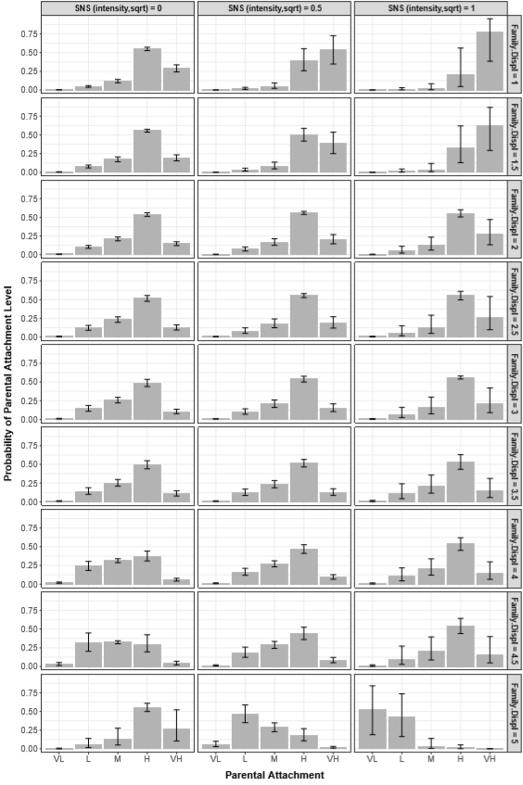
Note. Separate columns for low (0), medium (.5), and high (1) levels of scaled independent variable (SNS intensity square root transformed). X-axis reflects each level of parental attachment, from very low (VL), low (L), moderate (M), high (H), to very high (VH). Y-axis reflects probability (with confidence intervals) of belonging to each parental attachment level; higher values equate with high probability. Separate rows for different levels of the moderator (family displacement) from 1 (low) to 5 (high).

Supplementary Figure 2. AIC decision tree values for parental warmth and parental attachment.

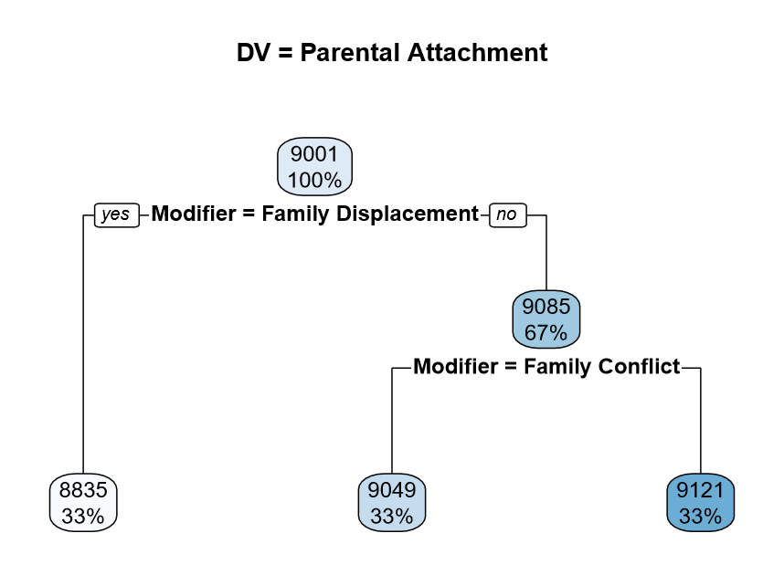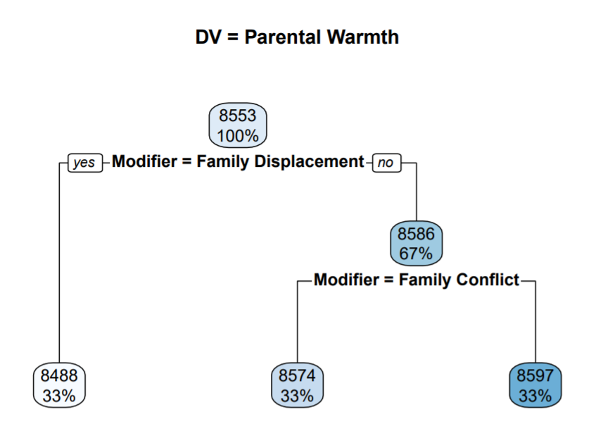
Note. AIC decision trees for parental attachment (left) and parental warmth (lef) . Lower AIC values indicate better relative fit. Parental warmth models overall have better fit; and for both dependent variables, models with family displacement as a modifier (left side of tress) have the lowest AIC value (best fit).

